CSUS EEE 174 Lab - Section 4 - Tuesday

Laboratory Experiment Number 5: Lab Report

**Analog Discovery Lab**



**Introduction**

The objective of this lab is to discover the functions of USB Oscilloscope Analog Discovery. Some functions usually needed for an electrical engineering workstation, include the oscilloscope, the waveform generator, and the voltage supply source are all integrated into the Analog Discovery Kit. By performing this lab, we will be able to understand the power of the Analog Discovery and how it will help in any other projects.

1. **Oscilloscope and Waveform Generator**

First of all, I need to setup the Analog Discovery Kit and connect it according to the instructions in the video provided. In order to have the connection from the kit to the computer, we need to to download the software from the Digilent website. Once the software downloaded, some basic functions of the kit were worked through such as: voltage too, oscilloscope, waveform generator and so onl. The voltage tool allows control of the discovery kits power supply using simple on and off buttons; the scope’s primary function is to measure voltage difference, but even more impressively, it can analyze data such as frequency, amplitude, and period of the generated signal. Lastly, the AWG (arbitrary waveform generator) is used to output a user defined signal, which is usually periodic.

After the introduction about the basic functions of the kit, channel 1 of the waveform generator was connected to the positive terminal of channel 1 of the oscilloscope, while connecting the negative terminal (orange-white strap) to any ground terminal. Afterwards, a 1 KHz sinusoidal signal waveform, 3.3 V Amplitude, 0 DC offset was generated, and oscilloscope was opened to measure and observe the signal. Once we familiarize ourselves with the, we begin to change the frequency and amplitude to see how it varies the signal. The screenshot of the setting in the Analog Discovery Software is:

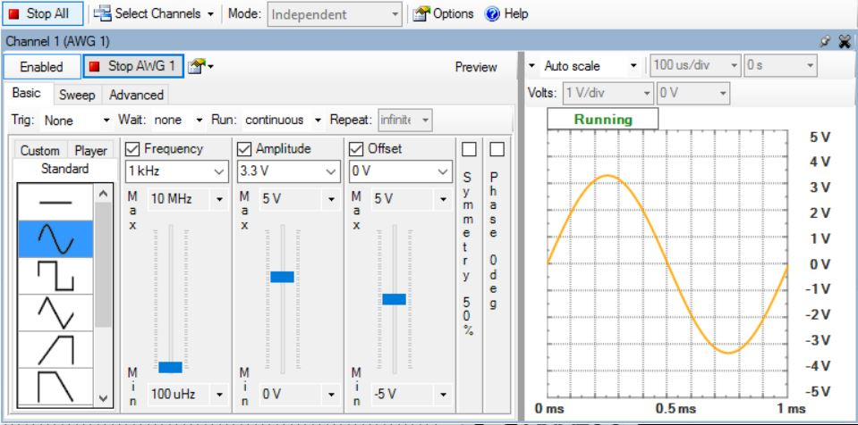

Once it runs, the oscilloscope window is displayed with 1V/division, as below:

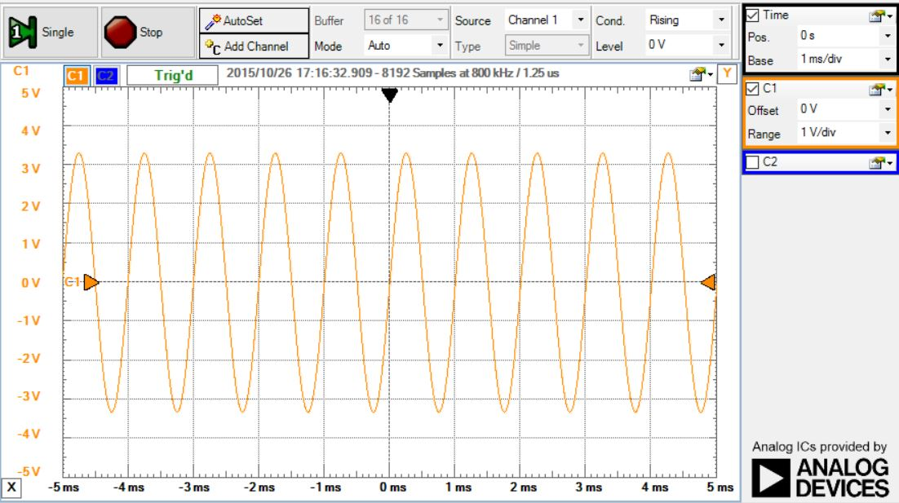

1. **Voltage Tool**

The objective of this part is to gain a better understanding of how the voltage tool functions work in the Analog Discovery Kit. Following the instruction, a simple circuit with a LED is built along with a 100resistor in series.The red wire indicating V+ was connected in series with the 100Ω resistor to supply the circuit with a DC source of 5 Volts. Similarly, though the black wire indicating ground is directly connected towards the LED’s positive leg. Then, by clicking the voltage tool and pressing power, we successfully supplied the voltage to the circuit and lighted up the LED as the picture below:

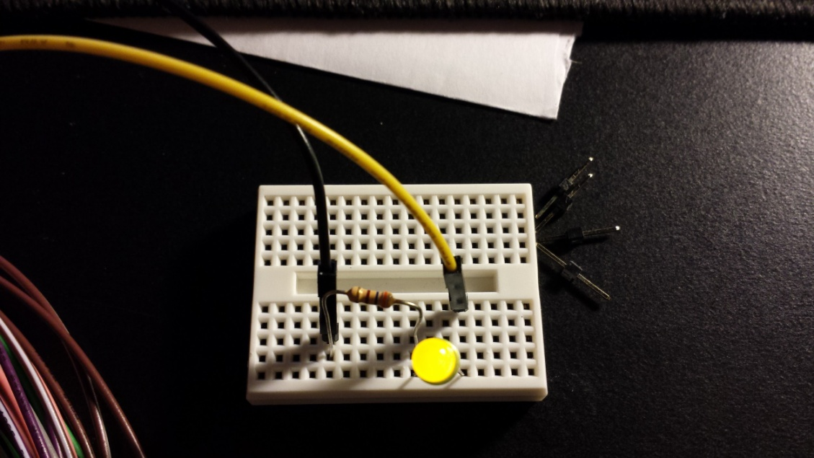

1. **Voltmeter Tool**

The objective of this part is to examine the function of the Analog Discovery Kit’s voltmeter tool by using the circuit in part 2. The voltmeter tool helps measuring and displaying the voltage across the channels used to measure. As depicted below, channel 1 with orange wire is measuring the voltage across the LED and channel 2 with blue wire is measuring the voltage of the resistor.

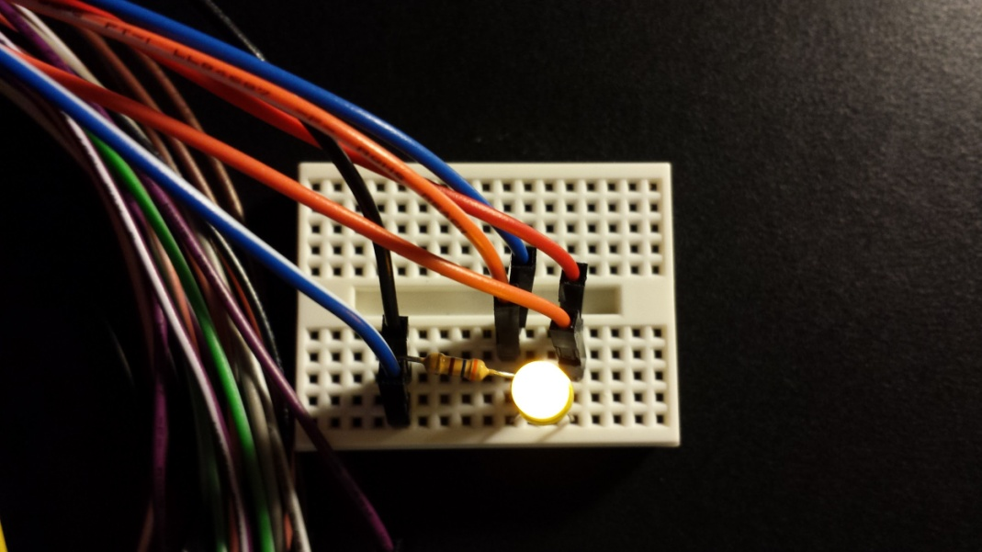

Once all circuit connections were made we click on more instruments and open up voltmeter. The result window obtained with channel 1 and channel 2 values is:

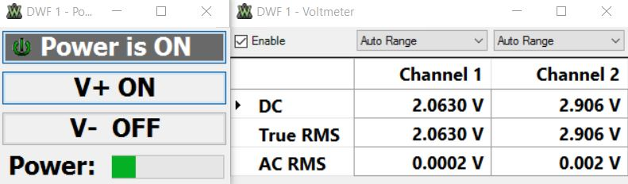

1. **Arbitrary Waveform Generator**

The objective of part four in this lab is to investigate the functions of the arbitrary waveform generator. An AC source was generated using the waveform generator to blink an led. Also, different commands of the waveform generator were tested by looking at the different type of signals arbitrary waveform generator. By choosing one of the three commands: standard, custom, and player along with different options for editing, we can choose the signals we output depending on our desires. Therefore, a sine wave starting at 10 percent and ending at 40 percent of the period was created and simulated as below:

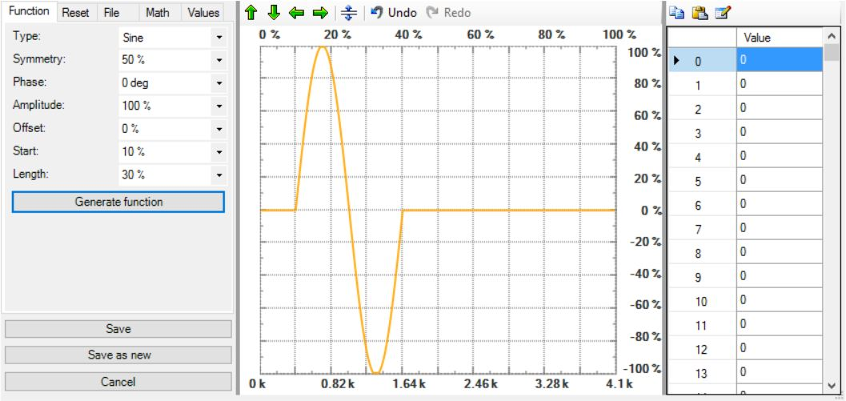

Next, a triangle wave starting at 70 percent and ending at 90 percent of the period was added to the previous waveform. Therefore, the final waveform looks like:

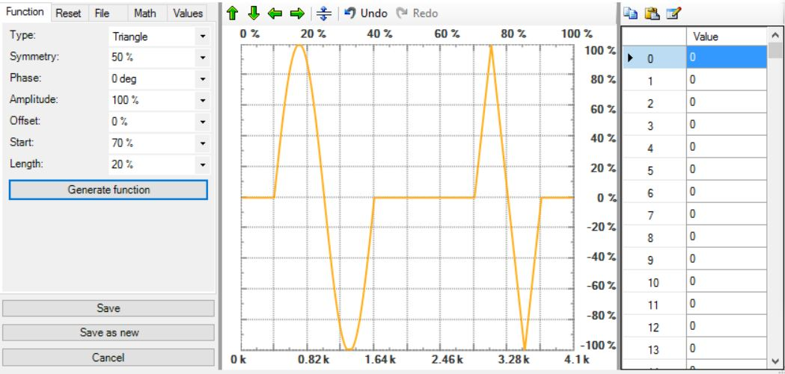

Again, circuit in part 2 is used for testing purposes. In this case, instead of using 5V DC supply, an AC waveform in yellow wire is used instead to power up the LED as below:

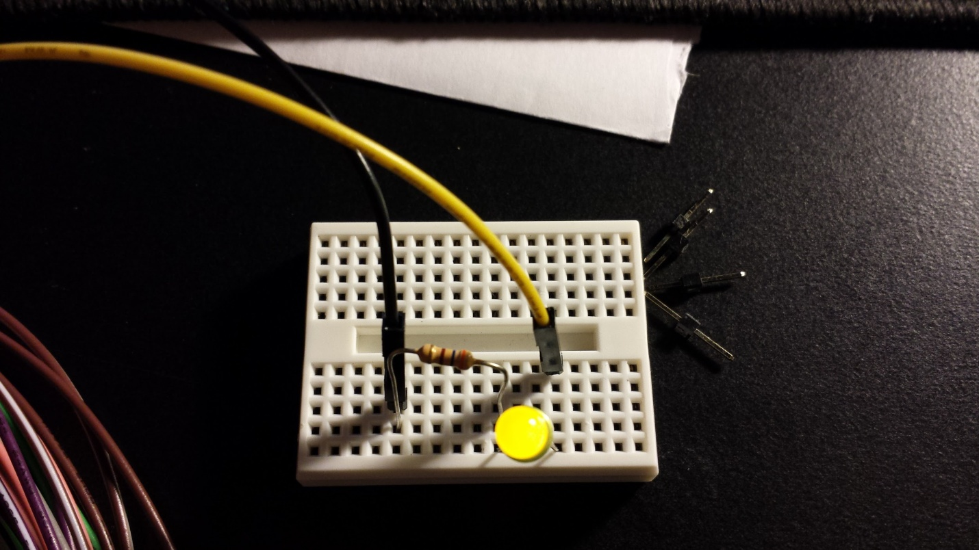

The specification of waveform has frequency of 500 mHz sinusoidal signal along with amplitude 4Vp-p and 0 DC offset. The setting of this waveform is shown below:

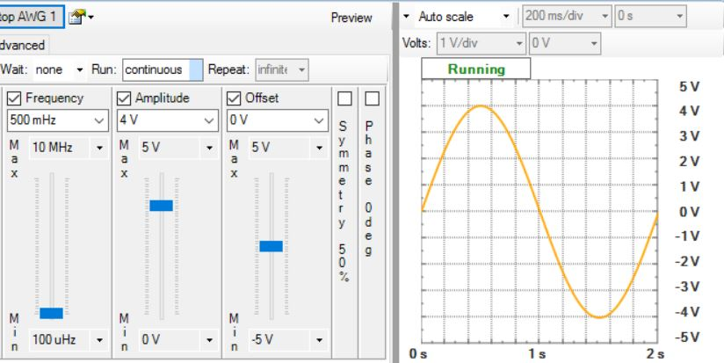 By feeding a sinusoidal input into the circuit the led would only blink when the sinusoidal source generates a voltage is greater than or equal to 2V due to the threshold voltage of LED, thus the LED would only turn on at a rate of every two seconds.

1. **The Oscilloscope**

The objective of this lab is to examine the function of the oscilloscope and its function to display voltage as a function of time, so we are able to view the time varying function directly. By observing waveform obtained from the oscilloscope, the behavior of any circuit will be analyzed and understood more thoroughly. Using the circuit built in part 4 with AC signal generator, we set the following specifications for the input signals: triangle form with frequency of 1.3Hz, 3V amplitude and 0V DC offset as below:

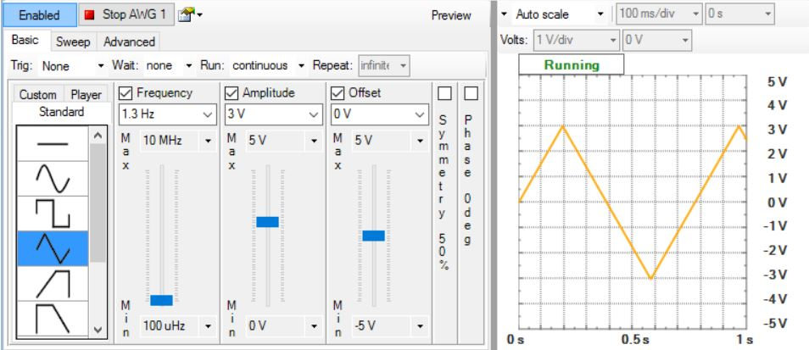

In physical circuit, the LED is normally on as expected from part 4’s successful build. Now, by looking at the oscilloscope window, the voltage across the LED was noticed clipping at its maximum value in the below picture due to the maximum voltage that the LED manufacturing setting is designed for.

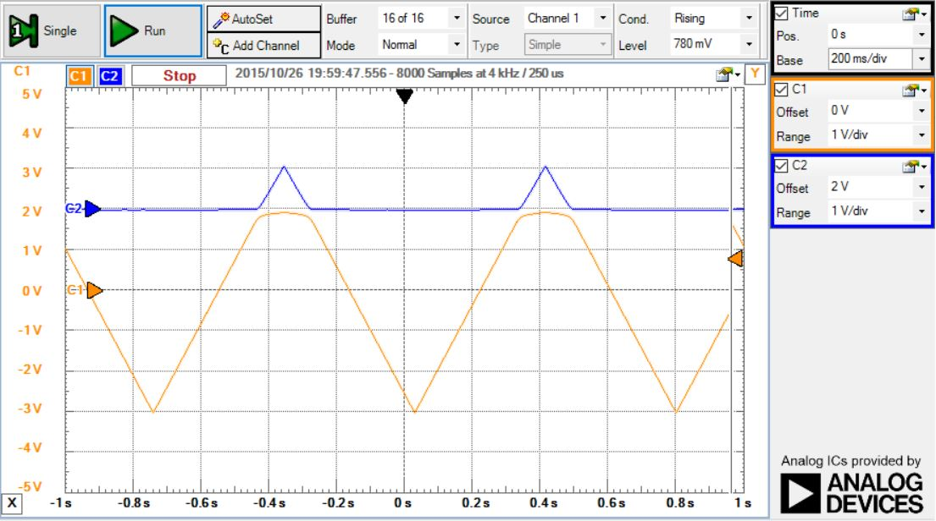

**Conclusion**

It was a great lab and learning experience for first time Analog Discovery Kit user. By understanding how powerful and how much work can be done using the Analog Discovery Kit from DC to AC level, we have found an alternative way for traditional electrical and electronics lab with separate function generator, DC power supply, digital multimeter and oscilloscope, and so on by a multi-function USB Oscilloscope Analog Discovery.